27.70: (a) During acceleration of the ions:
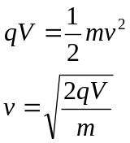
In the magnetic field:
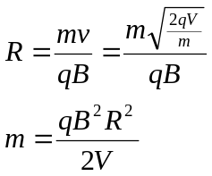
(b) 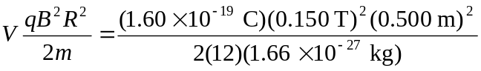
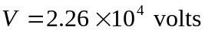

(c) The ions are separated by the differences in their diameters.

